Supplementary Appendix S1 Specimens used in morphological analysis (CIB: Chengdu Institute of Biology, Chinese Academy of Sciences; YBU: Yibin University).

Fujian: CIB 12231-33, CIB 78118.
Guizhou: CIB 12241-42.
Sichuan: CIB 12234-40, YBU 13044, YBU 18169.
Xizang: CIB 12243.
Yunnan: CIB78117.
Guangxi: YBU 16054, YBU 16066-67, YBU 16086.

Supplementary Appendix S2 Information on samples used in molecular phylogeny
Species | Voucher number | Locality | GenBank accession No.
Sinomicrurus houi | GP 2193 | Hainan, China | MN685875
Sinomicrurus houi | GP 4643 | Hainan, China | MN685883
Sinomicrurus houi | ROM 37079 | Hia Duong, Vietnam | MN685889
Sinomicrurus houi | GP 4839 | Guangxi, China | MN685884
Sinomicrurus houi | GP 1046 | – | MN685872
Sinomicrurus kelloggi | GP 2194 | Guangdong, China | MN685876
Sinomicrurus kelloggi | FJLWS01 | China | MG788980
Sinomicrurus macclellandi | GP 1059 | Hainan, China | MN685873
Sinomicrurus macclellandi | GP 1060 | – | MN685874
Sinomicrurus macclellandi | GP 2742 | Fujian, China | MN685877
Sinomicrurus macclellandi | GP 3360 | Sichuan, China | MN685878
Sinomicrurus macclellandi | GP 5500 | Sichuan, China | MN685885
Sinomicrurus macclellandi | CIBHN05 | – | MG653598
Sinomicrurus macclellandi | CIBHN06 | – | MG653599
Sinomicrurus macclellandi | CIBSC07 | – | MG653600
Sinomicrurus macclellandi | ZHSHS01 | – | MG788982
Sinomicrurus macclellandi | RN 0749 | Taiwan, China | KP749813
Sinomicrurus macclellandi | RN 0658 | Taiwan, China | KP749808
Sinomicrurus macclellandi | RN 0611 | Taiwan, China | KP749807
Sinomicrurus macclellandi | RN 1024 | Taiwan, China | KP749817
Sinomicrurus macclellandi | KIZ 011981 | China | MN685886
Sinomicrurus macclellandi | ROM 37110 | Tuyen Quang, Vietnam | MN685891
Sinomicrurus macclellandi | YPX 9241 | Bac Thai, Vietnam | MN685890
Sinomicrurus macclellandi | KIZ 011601 | Phu Tho, Vietnam | MN685887
Sinomicrurus macclellandi | ROM 31159 | Tuyen Quang, Vietnam | MN685892
Sinomicrurus peinani | YBU 16054 | Guangxi, China | MN685879
Sinomicrurus peinani | YBU 16066 | Guangxi, China | MN685880
Sinomicrurus peinani | YBU 16067 | Guangxi, China | MN685881
Sinomicrurus peinani | YBU 16086 | Guangxi, China | MN685882
Sinomicrurus peinani | ROM 31157 | – | MN685888
Sinomicrurus peinani | YPX 9244 | Cao Bằng, Vietnam | MN685893
Sinomicrurus peinani | YPX 9245 | Cao Bằng, Vietnam | MN685894
Sinomicrurus peinani | YPX 9246 | Vinh Phuc, Vietnam | MN685895
Sinomicrurus peinani | YPX 9247 | Vinh Phuc, Vietnam | MN685896
Sinomicrurus sauteri | RN 0285 | Taiwan, China | KP749804
Sinomicrurus hatori | RN 1455 | Taiwan, China | KP772310
Sinomicrurus sauteri | RN 0726 | Taiwan, China | KP749810
Sinomicrurus sauteri | RN 0745 | Taiwan, China | KP749812
Sinomicrurus sauteri | RN 1581 | Taiwan, China | KP749827
Micrurus lemniscatus | UPRP:314704 | Trinidad and Tobago | MH274442
Micrurus nigrocinctus | CH:5291 | Panama | MH140289
ROM: Royal Ontario Museum, Canada; KIZ: Kunming Institute of Zoology, the Chinese Academy of Science; YBU: Yibin University, China. YPX: Tissue no. in KIZ; GP: Peng Guo, tissue no. in YBU. –: Not available.

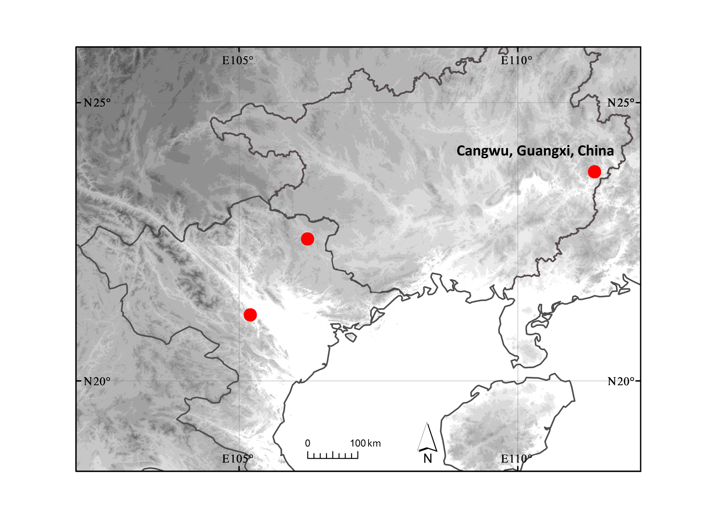

Supplementary Appendix S3 Map showing known localities of Sinomicrurus peinani sp. nov.

Supplementary Appendix S4 Average sequence divergence estimation (mean uncorrected P-distances, %) between species of Sinomicrurus
Taxa | Sinomicrurus houi | Sinomicrurus macclellandi | Sinomicrurus kelloggi | Sinomicrurus peinani | Sinomicrurus hatori | Sinomicrurus sauteri
Sinomicrurus houi
Sinomicrurus macclellandi | 14.6
Sinomicrurus kelloggi | 7.5 | 12.3
Sinomicrurus peinani | 12.8 | 12.5 | 12.5
Sinomicrurus hatori | 13.3 | 12.6 | 11.3 | 14.2
Sinomicrurus sauteri | 13.1 | 12.7 | 14.4 | 14.5 | 1.3

