Supplementary Methods
Morphology: Snout-vent length (SVL, from tip of snout to vent); head length (HL, from tip of snout to rear of jaws); head width (HW, width of head at its widest point); snout length (SL, from tip of snout to anterior border of eye); internarial distance (IND, distance between nares); interorbital distance (IOD, minimum distance between upper eyelids); upper eyelid width (UEW, maximum width of upper eyelid); eye diameter (ED, diameter of exposed portion of eyeball); tympanum diameter (TD, the greater of tympanum vertical and horizontal diameters); forearm and hand length (FHL, from elbow to tip of third finger); thigh length (THL, from vent to knee); tibia length (TL, distance from knee to heel); foot length (FL, from proximal end of inner metatarsal tubercle to tip of fourth toe); length of foot and tarsus (TFL, from tibiotarsal joint to tip of fourth toe); and horizontal diameter of digital disc of finger III (F3DSC).
PCR, sequencing and phylogenetic analyses: PCR amplifications were performed in 50 µL reactions using the following cycling conditions: an initial denaturing step at 95 ℃ for 4 min; 35 cycles of denaturing at 94℃ for 60s, annealing at 46–51℃ for 60s (46 ℃ for COI, 49 ℃ for ND2, and 51 ℃ for 16S), and extending at 72 ℃ for 60s; and a final extending step of 72 ℃ for 10 min. Sequencing was conducted directly using the corresponding PCR primers. Sequences were aligned using MUSCLE with the default parameters in MEGA 7 (Kumar et al., 2016). Uncorrected pairwise distances between species were calculated in MEGA 7. The best substitution model of combined data was selected using the Akaike Information Criterion (AIC) in MODELTEST v3.7 (Posada & Crandall, 1998). Bayesian inference was performed in MRBAYES 3.1.2 (Huelsenbeck & Ronquist, 2001) based on the selected substitution models (GTR+I+G). Two runs were performed simultaneously with four Markov chains starting from random tree. The chains were run for 5 000 000 generations and sampled every 100 generations. The first 25% of the sampled trees was discarded as burn-in after the standard deviation of split frequencies of the two runs was less than a value of 0.01, and then the remaining trees were used to create a consensus tree and to estimate Bayesian posterior probabilities (BPPs).

REFERENCES
Huelsenbeck JP, Ronquist F. 2001. MrBayes: Bayesian inference of phylogeny. Bioinformatics, 17: 754–755.
Kumar S, Stecher G, Tamura K. 2016. MEGA7: molecular evolutionary genetics analysis version 7.0 for bigger datasets. Molecular biology and evolution, 33 (7): 1870–1874.

Supplementary Table S1 Sequences and voucher speciemens of Amolops used in this study
Species | Voucher | Locality | 16S | CO1 | ND2
Amolops akhaorum | FMNH 271357 | Vieng Phou Kha, Luang Namtha, Laos | FJ417160 | – | FJ417209
Amolops aniqiaoensis | KIZ 011138 | Medog, Tibet, China | – | KU243073 | –
Amolops archotaphus | CUMZ A 2000.69 | Doi Inthanon, Chiang Mai, Thailand | FJ417123 | – | FJ417172
Amolops afghanus | CAS230228 | Kachin, Myanmar | JF794430 | – | FJ417205
Amolops bellulus | – | – | FJ417126 | KU243079 | FJ417175
Amolops chunganensis | QLY313 | Shenglongjia, Hubei, China | KF771285 | KF771328 | KF771328
Amolops chunganensis | SYS a004213 | Mt. Jinggang, Jiangxi, China | MG991886 | MG991915 | –
Amolops compotrix | ZISP A7367 | Dak Glei, Kon Tum, Vietnam | FJ417142 | – | FJ417191
Amolops cucae | AMNH 168729 | Van Ban Dist., Ha Giang Vietnam | FJ417145 | – | FJ417194
Amolops chayuensis | SYS a007509 | China, Xizang, Baxoi County  in  a  : X  iz  a  n  g  : B  a  x  o  i  C  o  u  n  ty | MK573820 | MK568333 | –
Amolops cremnobatus  .  c  r  em  n  o  b  a  tu  s | FMNH 258377 | Laos, Vientiane, Kasi | FJ417143 | – | FJ417192
Amolops daorum | ROM 38501 | Sa Pa, Lao Cai, Vietnam | FJ417150 | – | FJ417199
Amolops granulosus | SYS a005316 | China, Sichuan, Mt. Wawu | MK604851 | MK605609 | KF771329
Amolops indoburmanensis | CAS 235070 | Myanmar, Chin, Twi Rein | JF794446 | – | –
Amolops iriodes | AMNH 163925 | Vi Xuyen Dist., Ha Giang, Vietnam | FJ417154 | – | FJ417203
Amolops jinjiangensis | SYS a004571 | China, Yunnan, Mt. Gaoligong | MK573801 | MK568316 | –
Amolops loloensis | SM-ZDTW-01 | China, Sichuan, Shimian | KT750963 | KT750963 | KT750963
Amolops loloensis | SCUM045807HX | China, Sichuan, Xichang City | EF453743 | – | –
Amolops lifanensis | SYS a005378 | China, Sichuan, Lixian County | MK604870 | MK605628 | –
Amolops mantzorum | – | Mt.Xiling Snow,Dayi,Sichuan,China | KJ546429 | KJ546429 | KJ546429
Amolops mantzorum | SYS a005365 | Fengtongzhai, Sichuan, China | MK573808 | MK568323 | –
Amolops marmoratus | – | Thailand | AB211486 | – | –
Amolops marmoratus | CAS 240593 | Myanmar, Mon | JF794456 | – | –
Amolops mengdingensis | KIZ 20160265 | Mengding, Yunnan, China | MK501808 | MK501811 | MK501814
Supplementary Table S1 (Continued)
Species | Voucher | Locality | 16S | CO1 | ND2
Amolops mengyangensis | 1999.5811 | Sa Pa, Lao Cai, Vietnam | KR827703 | KR087618 | –
Amolops mengyangensis | 1999.5812 | Sa Pa, Lao Cai, Vietnam | KR827704 | KR087619 | –
Amolops medogensis | SYS a006657 | China, Xizang, Medog County | MK573813 | MK568328 | –
Amolops nyingchiensis | KIZ 012632 | Paizhen, Tibet, China | – | KU243071 | –
Amolops panhai | 0332Y | Thailand, Ratchaburi, Kao Chan water fall | KR827705 | KR087620 | –
Amolops shuichengicus | SYS a004956 | China, Guizhou, Shuicheng County | MK604845 | MK605603 | –
Amolops tuanjieensis sp. nov. | GXNU YU110003 | Tuanjie, Yunnan, China | MN832772 | MN832750 | MN832755
Amolops tuanjieensis sp. nov. | GXNU YU110005 | Tuanjie, Yunnan, China | MN832773 | MN832751 | MN832756
Amolops tuanjieensis sp. nov. | GXNU YU110006 | Tuanjie, Yunnan, China | MN832774 | MN832752 | MN832757
Amolops tuanjieensis sp. nov. | GXNU YU110007 | Tuanjie, Yunnan, China | MN832775 | MN832753 | MN832758
Amolops tuanjieensis sp. nov. | GXNU YU110034 | Tuanjie, Yunnan, China | MN832776 | MN832754 | MN832759
Amolops tuberodepressus | CIB-XM3125 | China, Yunnan, Jingdong | KR559270 | KR559270 | KR559270
Amolops viridimaculatus | SYS a003813 | China, Yunnan, Mt. Gaoligong | MK604836 | MK605597 | –
Amolops vitreus | FMNH 258183 | Phongsaly Dist., Phongsaly, Laos | FJ417163 | – | FJ417212
Amolops wenshanensis | KU292045 | Jingxi, Guangxi, China | FJ417129 | – | FJ417178
Amolops ricketti | – | China, Jiangxi, Wugong Mountain | KF956111 | KF956111 | KF956111

–: Not available.

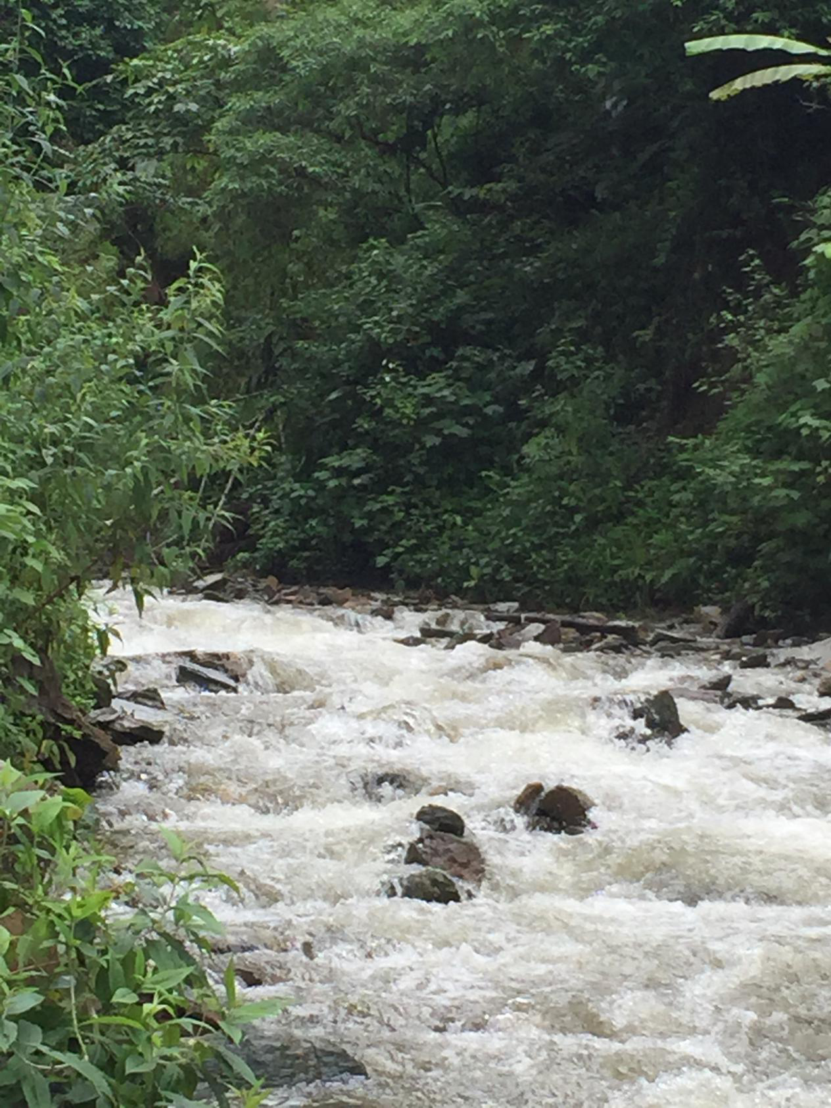
Supplementary Figure S1 Habitat of Amolops tuanjieensis sp. nov. at the type locality

