SUPPLEMENTARY MATERIAL
SUPPLEMENTARY MATERIAL AND METHODS
Study area
The present study was conducted on the Tianping Mountain, the core region of Badagongshan National Nature Reserves, which is located in northwest Hunan Province, China (N29.714072°–29.787100°, E109.906154°–110.170800°). The elevational gradients are from 300 to 1 890 m, covering three distinct climatic zones. Specifically, the low elevation area (<800 m) is warm, with the mean annual temperature ranging from 13.7 to 15.9 °C. This is the hilly agriculture-forestry zone, where the vegetation is dominated by crops and evergreen broad-leaved forest. The mean annual temperature of medium elevation area (800–1 400 m) is 12.2–13.7 °C, which corresponds to evergreen broadleaf forest zone. The high elevation area (1 400–1 890 m) is composed of evergreen deciduous broadleaf forest, which has strong wind, heavy rain, and heavy snow during winter, and the mean annual temperature is below 10.0 °C (Xiong et al., 1999).

Amphibians sampling
Ten transects (200 m×2 m) were randomly selected from low to high elevational gradients (Figure S1), which located along stream tributaries. These transects were separated from each other by a deep mountain gorge and/or streams to reduce the spatial autocorrelation, with more than 1.5 km of the pairwise distance existing between them. Amphibian communities sampling were conducted in April, June, August, and October in 2017, separately. These four times sampling events were corresponded with distinct seasons (i.e., spring, early summer, midsummer, and autumn), covering the breeding, foraging, and migration seasons of amphibians. We used the combination of distance sampling and quadrat sampling methods following Zhao et al. (2018) and Khatiwada et al. (2019), which has been proved effectively to sample the combination of anurans and stream amphibians (e.g., salamanders, Funk et al., 2003; Dodd, 2010). All of the captured individuals were identified to species, determined to developmental stages (adult or juvenile), measured for snout-vent length to the nearest mm, weighted, photographed, toe-clipped (molecular identification was used if individuals cannot be identified based on morphological traits), and then released back to the sites from which they were captured.

Environmental factors
A set of 16 environmental factors associating with biotic and abiotic features of amphibians microhabitat were select based on previous studies demonstrating that they can potentially play important roles in shaping amphibian assemblages (Grundel et al., 2015; Keller et al., 2009; Khatiwada et al., 2019; Wyman, 1988; Wyman & Jancola, 1992). Details of the environmental factors and the related methodologies that used to collect them were as follows: air temperate was measured using a mercury thermometer. Air humidity was measured by a digital humidity meter (Peakmeter MS6508). Altitude was recorded by using a GPS (ICEGPS 660). Water depth, water width, fallen leaf depth were measured five times within 20m in each transect by using a steel tape, and the average values were used to do the analyses. Canopy cover (%) of the vegetation was measured following Lemmon (1957) by using a spherical densitometer, with five locations were selected and four directions (N, S, E, W) were measured in each location, and we also used the average values to do the analyses. Tree number was recorded in each transect (i.e., all of the trees located in the 200 m×2 m transect). Shrub coverage, fallen leaf coverage, and rock coverage were averaged by five locations data, with each location was estimated by the same person. Soil pH was recorded using a soil pH Meter (ZD-05, Zhengda, China). Water temperature, water pH, and conductivity were measured by using a portable fluorescence photometer (Orion, Thermo Fisher Scientific, USA). Water velocity was recorded five times using a velocimeter (Xiangruide, LS1206B, China) in each transect, and the average value was used for subsequent analyses. In total, all of the environmental factors in each transect were measured four times (i.e., at April, June, August, and October, respectively; Table S2).

Statistical analyses
We first performed a detrended correspondence analysis (DCA; Hill & Gauch, 1980) to determine whether redundancy analysis (RDA) or canonical correspondence analysis (CCA) would be the most appropriate model to describe the association between amphibian species composition (i.e., life stages level) and environmental factors. The DCA ordination gradient was 1.12 SD, suggesting that the linear model associated with RDA was the appropriate model to describe the association between amphibian species composition and environmental factors (ter Braak, 1986). The importance of each environment factor in the biplot was indicated by the length and angle of the vectors. We subsequently used Monte Carlo permutation test with 999 permutations to test whether environment factors significantly explained amphibian assemblages data. A forward selection procedure with 999 permutations was used to test the contributions of each environmental factor on all axes conjointly (Zhao et al., 2016). Species richness was represented by the number of species. The response of amphibian species richness to elevational gradients (spatial variation) was tested using linear regressions. Since the relationship may be either non-monotonic (U shape and hump-shape) or monotonic (linear), a quadratic term was included in the models that were subsequently retained only if significant (P<0.05; Crawley, 2007). Finally, we conducted a Friedman test with a Wilcoxon rank sum test to compare the potential differences of amphibian species richness between four months (i.e., seasons). All statistical analyses were conducted in R 3.60 (R Development Core Team, 2011).

REFERENCES
Crawley M. J. 2007. The R book. New York: Wiley.
Dodd, C. K. 2010. Amphibian Ecology and Conservation: a Handbook of Techniques. New York: Oxford University Press.
Funk, W. C., Almeida-Reinoso, D., Nogales-Sornosa, F., & Bustamante, M. R. 2003. Monitoring population trends of Eleutherodactylus frogs. Journal of Herpetology, 37: 245–256.
Grundel, R., Beamer, D. A., Glowacki, G. A., Frohnapple, K. J., & Pavlovic, N. B. 2015. Opposing responses to ecological gradients structure amphibian and reptile communities across a temperate grassland–savanna–forest landscape. Biodiversity and Conservation, 24: 1089–1108.
Keller, A., Rödel, M.-O., Linsenmair, K. E., & Grafe, T. U. 2009. The importance of environmental heterogeneity for species diversity and assemblage structure in Bornean stream frogs. Journal of Animal Ecology, 78: 305–314.
Khatiwada, J. R., Zhao, T., Chen, Y., Wang, B., Xie, F., Cannatella, D. C., & Jiang, J. 2019. Amphibian community structure along elevation gradients in eastern Nepal Himalaya. BMC Ecology, 19: 19.
Lemmon, P. E. 1957. A spherical densiometer for estimating forest overstory density. Forest Science, 2: 314–320.
R Development Core Team. 2011. R: a language and environment for statistical computing. R Foundation for Statistical Computing, Vienna, Austria. Avilable at: http://www.R-project.org/.
ter Braak, C. J. F. 1986. Canonical correspondence analysis: a new eigenvector technique for multivariate direct gradient analysis. Ecology, 67: 1167–1179.
Wyman, R. L. 1988. Soil acidity and moisture and the distribution of amphibians in five forests of Southcentral New York. Copeia, 1988: 394–399.
Wyman, R. L., & Jancola, J. 1992. Degree and scale of terrestrial acidification and amphibian community structure. Journal of Herpetology, 26: 392.
Xiong, E., Zhu, K., You, L., Wang, Y., Fu, P., Gu, R., & Xiao, Z. 1999. Investigation on butterflies in Sangzhi County and Tianping Mountain natural preservation region. Journal of Hunan Agricultural University, 25: 312–317 (in Chinese with English abstract).
Zhao, T., Grenouillet, G., Pool, T., Tudesque, L., & Cucherousset, J. 2016. Environmental determinants of fish community structure in gravel pit lakes. Ecology of Freshwater Fish, 25: 412–421.
Zhao, T., Wang, B., Shu, G., Li, C., & Jiang, J. 2018. Amphibian species contribute similarly to taxonomic, but not functional and phylogenetic diversity: inferences from amphibian biodiversity on Emei Mountain. Asian Herpetological Research, 9: 110–118.
Supplementary Table S1 Species (and the abbreviation) that were captured on the Tianping Mountain
Oder | Family | Species | Abbreviation
Anura | Bufonidae | Bufo gargarizans | bug
 | Ranidae | Amolops chunganensis | amc
 |  | Amolops ricketti | amr
 |  | Odorrana margaretae | odm
 |  | Odorrana schmackeri | ods
 |  | Pseudorana sangzhiensis | pss
 | Dicroglossidae | Fejervarya multistriata | fem
 |  | Feirana quadranus | naq
 |  | Paa boulengeri | pab
 | Rhacophoridae | Rhacophorus chenfui | rhc
 | Hylidae | Hyla gongshanensis | hya
 | Megophryidae | Paramegophrys liui | pal
 |  | Leptobrachium boringii | leb
 |  | Megophrys sangzhiensis | mes
Caudata | Hynobiidae | Pseudohynobius flavomaculatus | psf

Supplementary Table S2 Environmental factors (name and abbreviation) measured in each transect
Name | Abbreviation | Range | Mean (SD)
Air temperate (°C) | AT | 9.17–25.13 | 17.82(4.41)
Air humidity (%) | AH | 55.03–99.53 | 80.65(12.08)
Water temperate (°C) | AT | 10.00–21.47 | 14.27(2.86)
pH-water | WpH | 6.27–7.12 | 6.59(0.23)
Altitude (m) | Alt | 467–1492 | 1 084(428)
Water depth (mm) | WD | 10.30–93.33 | 36.38(25.71)
Water width (m) | WW | 1.57–20.00 | 5.85(5.51)
Tree number | TN | 0–204 | 67(72)
Canopy density (%) | CD | 0–80.83 | 37.08(34.29)
Shrub coverage (%) | SC | 0–46.88 | 16.70(14.74)
Fallen leaf coverage (%) | FLC | 0–15.00 | 4.82(5.29)
Fallen leaf depth (mm) | FLD | 0–3.60 | 1.35(1.36)
Rock coverage (%) | RC | 2.50–100.00 | 29.96(25.42)
Flow rate (cm/s) | FR | 13.92–47.16 | 24.87(9.15)
pH-soil | SpH | 6.27–7.00 | 6.63(0.19)
Water conductivity (μS·cm⁻¹) | WC | 16.49–294.67 | 103.38(85.88)

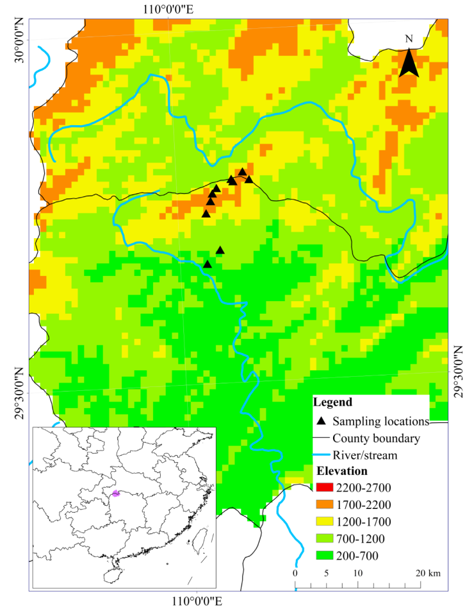
Supplementary Figure S1 Map of the study area showing the Tianping Mountain, China
The triangles denote transects used in the present study to survey amphibians.

